**YouTube Data Documentation**

Quick Note: I forgot to add df.to_csv("TATE_youtube.csv", **index=False**)

which is why the indexing is weird.

df = pd.read_csv('Tate_youtube.csv')

df = df.drop(columns=['Unnamed: 0'])

You can just drop it for future reference.

**Tate_youtube.csv**

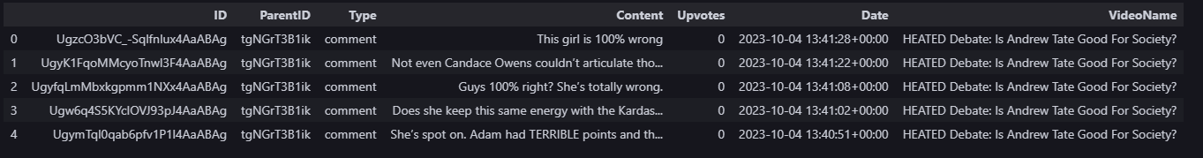

**ID –** Unique comment / reply ID

**ParentID –** Parent Comment ID & Video ID

**Type** **–**  comment or reply

**Content -** Comment

**Date -** %Y-%m-%d %H:%M:%S

**VideoName –** Name of Video

**How the Comment Thread is Listed:**

1. **Parent Comment – First Comment in a Thread**
   1. **ParentID =** VideoID
   2. **Type** = comment
2. **Reply**
   1. **ParentID** = The ID of the *parent comment* being replied to.
   2. **Type** = reply

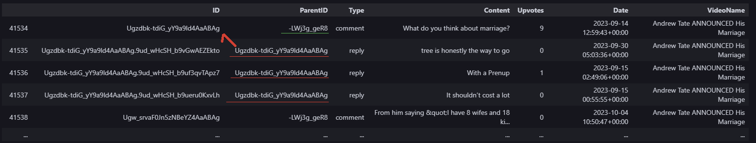

**Code**

df = pd.read_csv('Tate_youtube.csv')

df = df.drop(columns=['Unnamed: 0']) # forgot index=False when to_csv()

videogroup = df.groupby('ParentID') # Where the Parent Comments are

video_reply = {}

# Filtering out the videos to find the Parent comment (only need video_no_reply)

video_no_reply = {}

# Creating 2 DataFrames depending on if the df.Type is ‘comment’ or ‘reply’

for v_id, g_df in videogroup:

no_reply = g_df[g_df.Type == "comment"]

# Technically if the lengths are the same, there's no reply

if len(g_df) == len(no_reply):

video_no_reply[v_id] = no_reply

else:

video_reply[v_id] = g_df

# Combining all the DataFrames from the dictionary

df_no_reply = pd.concat(video_no_reply.values(), ignore_index=True)

df_no_reply.head()

# I want the TopComment ParentID

video_id = "-LWj3g_geR8"

top_level_comments = df[(df.ParentID == video_id) & (df.Type == "comment")]

top_level_comment_ids = top_level_comments['ID'].tolist()

all_comments_replies = df[df['ID'].isin(top_level_comment_ids) | df['ParentID'].isin(top_level_comment_ids)]

all_comments_replies